MERFIN SHARES & STOCK BROKING PVT LTD



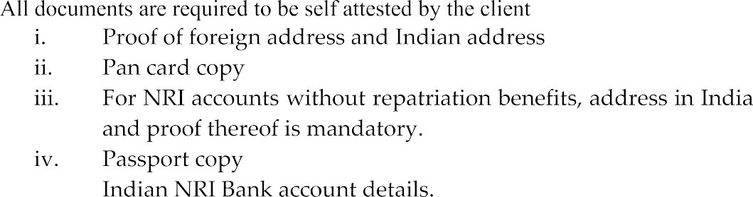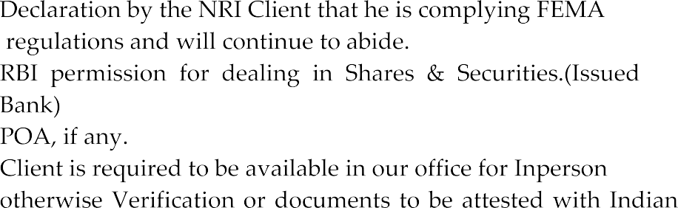

embassy









MERFIN SHARES & STOCK BROKING PVT LTD



|  |  |
| --- | --- |
|  |  |
|  |  |
|  |  |
|  |  |
|  |  |
|  |  |
|  |  |
|  |  |
|  |  |
|  |  |
|  |  |
|  |  |
|  |  |
|  |  |
|  |  |
|  |  |
|  |  |
|  |  |
|  |  |
|  |  |
|  |  |
|  |  |
|  |  |
|  |  |